Introduction to Computer Networks Labsheet1

Analyzing the End Device connectivity to the Network
Part1: Gather basic TCP/IP configuration information
Use the Start menu to open the Command Prompt, an MS-DOS-like window. Press Start
Programs > Accessories > Command Prompt or Start > Programs > Command Prompt.
The following figure shows the Command screen.
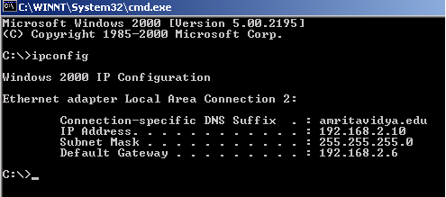
Type ipconfig and press the Enter key.
Note: ifconfig is the command in Ubuntu machine
It is short for IP Configuration. This first screen shows the IP address, subnet mask, and default gateway. The IP address and the default gateway should be in the same network or subnet, otherwise this host would not be able to communicate outside the network
Record the following TCP/IP information for your computer
IP address: fe80::dfc2:1692:af3f:352b%10 10.113.21.90
Subnet Mask: 255.255.0.0
Default Gateway: fe80::1%10 10.113.0.1

Part2- Using ping and tracert to troubleshoot connecting to the Internet
Objective
Learn to use the TCP/IP Packet Internet Groper (ping) command from a PC/laptop.
- Learn to use the Traceroute (tracert) command from a workstation.
- Observe name resolution occurrences using WINS and/or DNS servers.
Ping the IP address of another computer
- ping the IP address of the default gateway
- ping the IP address of a DHCP or DNS server
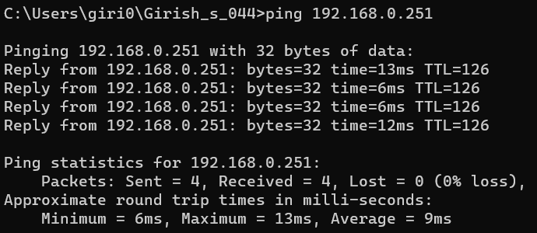
- Find the IP address of any one web server
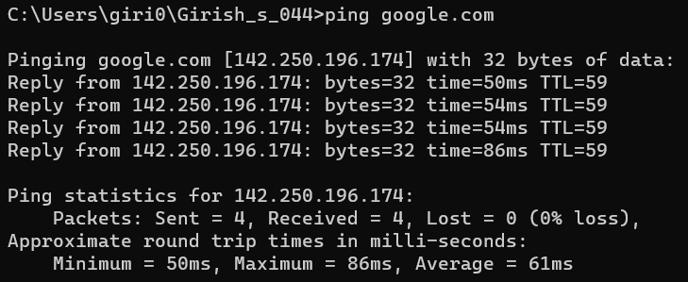
- Find the IP address of any one search engine
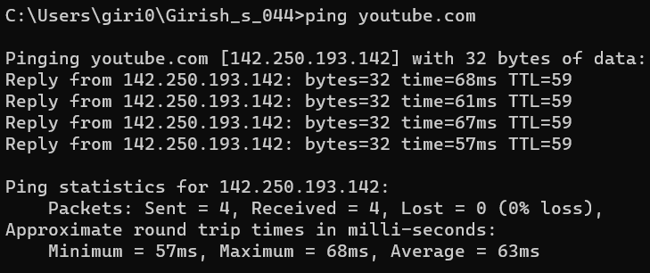
- Trace a local host name or IP address
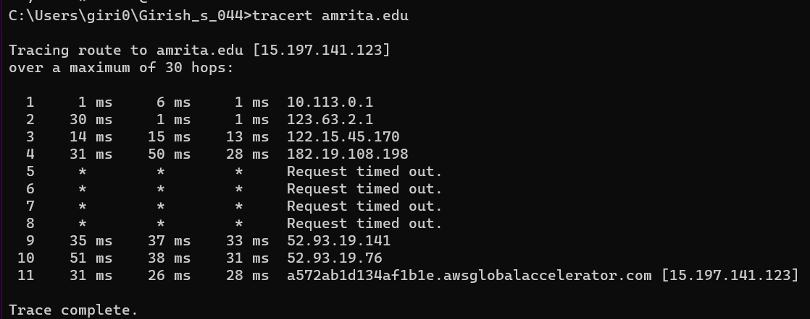
- Trace other IP addresses or domain names
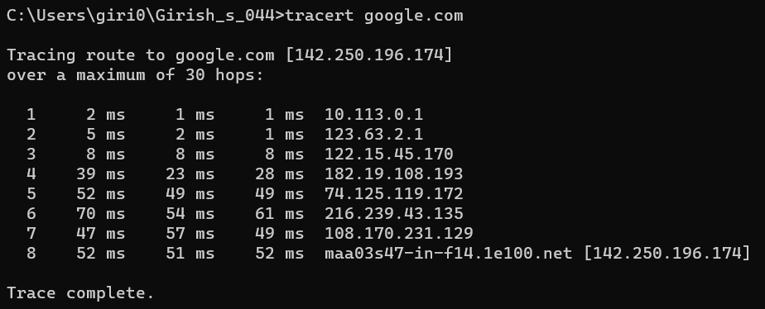
Part-3: What is the speed of your Internet Access?
Upload speed : 9.33Mbps
Download speed : 8.90Mbps
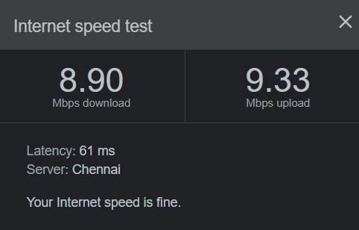
Part-4: How do you access the Internet in your home?
Mobile network

